Data Protection Compliance (DPC) Module

**Description**

* This module can be used to make Mendix Applications Compliant with Data Protection Acts and General Data Protection Regulations (GDPR).
* Non-Relevant Personal Identifiable information of Application Users’ can be scheduled to anonymization and will be replaced with random string variables on scheduled date.
* Required Data Protection Compliance Disclaimers can be created, updated, and managed. It can also be made accessible to Application Users.
* Required Data Protection Compliance or Policy documents can be created, updated, and managed. Also, can be made accessible to Application Users.

**Typical Usage Scenario**

Irrelevant Personal Identifiable information of Application Users’ can be scheduled to anonymization and anonymized from database. GDPR Disclaimers and Policy Statements can be managed. Also, Policy or GDPR Agreement Documents can be managed.

**PreRequisites**

NA

**Features and Limitations**

* This module can be used to make Mendix Applications Compliant with Data Protection Acts and General Data Protection Regulations (GDPR).
* Non-Relevant Personal Identifiable information of Application Users’ can be scheduled to anonymization and will be replaced with random string variables on scheduled date.
* Required Data Protection Compliance Disclaimers can be created, updated, and managed. Also, can be made accessible to Application Users.
* Required Data Protection Compliance or Policy documents can be created, updated, and managed. Also, can be made accessible to Application Users.

**Dependencies**: Require Mendix 9.1.0 or above.

# Installation

* Add Microflow “ASU_Create_DPC_Configuration” to After Start-Up microflow in app settings.
* Create a new page of your choice and add Snippet “Snip_DPC_Overview” to it. This page is used to manage all configurations and resources related to this module.
* Add Microflow “ACT_UserAccount_SetToAnonymization” in Account Overview Page. Identify the Users whose Personal Information or account is no longer required (E.g., Users who has left the company). Select the Account and click on the button calling above microflow. This user will get scheduled for anonymization based on DPC Configuration.
* All Privacy or Data Protection Disclaimers can be created and managed from

“DPC_Overview” page.

* All Data Protection Compliance or Policy Documents can be uploaded and managed from

“DPC_Overview” page.

# Cover Image:

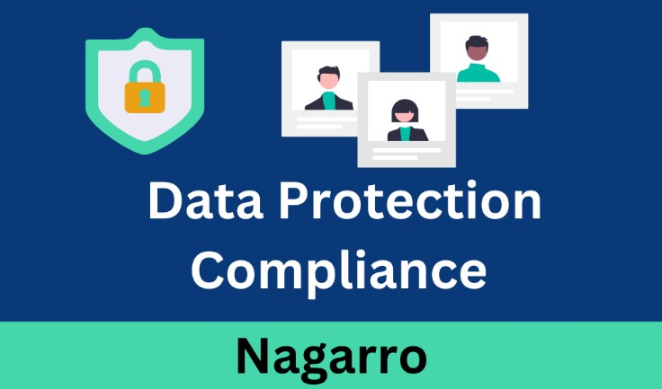

**Screenshots:**

